**Slickflow configuration documentation**

1. **development environment**
2. Operating system: Window7 and above
3. Programming language: VS2022(C#) and above, .NET6
4. Database version : (SQLSERVER2008) or above
5. Engine core component reference: under the reference directory (only for customer trial version 60days)
6. **project settings**
   1. **Slickflow Designer process designer**
7. **Front-end project sfd**

Project environment: npm (environment configuration executes npm install command)

Directory path : source\sfd\ClientApp

Run command execution: npm run dev

The backend service address is set in the kconfig.js file to point to

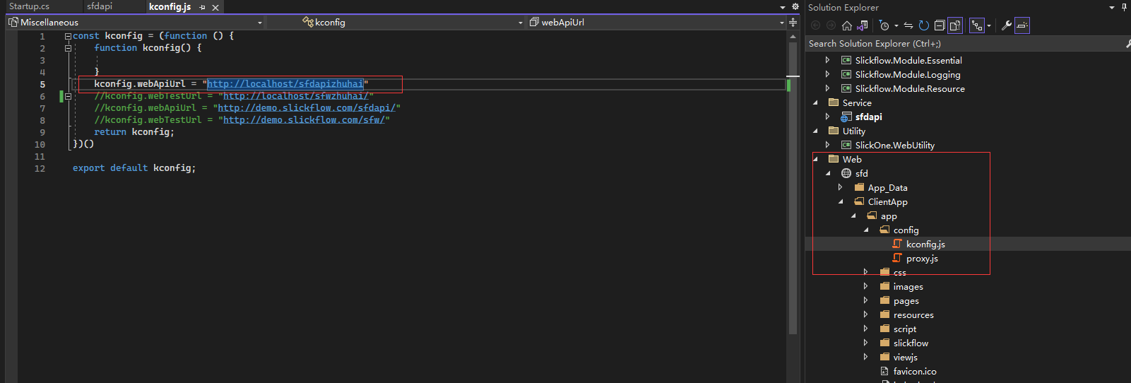

Example: The configuration in the kconfig.js file is as follows:

kconfig.webApiUrl = <http://localhost/sfdapizhuhai>

1. **Backend WebAPI service sfdapi**

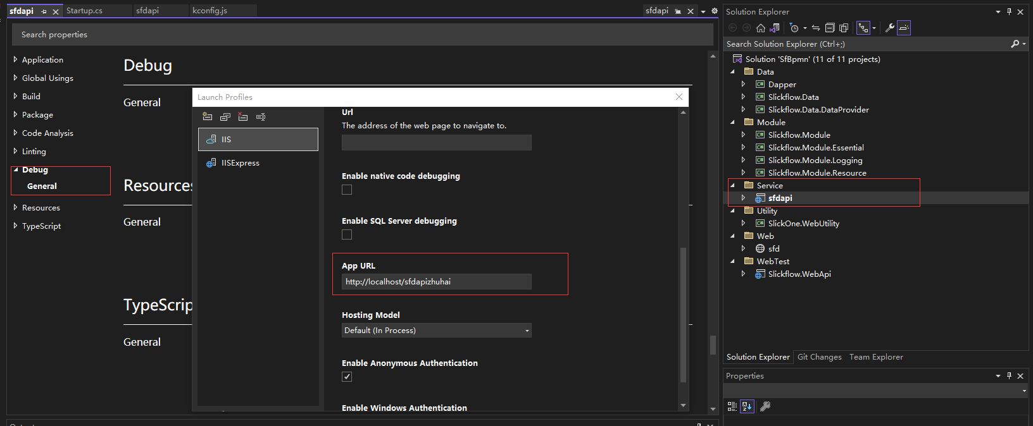

1. **database connection string**

appsetting.json file

C:\Users\lg\AppData\Roaming\Tencent\Users\47743901\QQ\WinTemp\RichOle\V8~0TA2U{%$8L8Y@$`KAA73.png

* 1. **Slickflow MvcDemo order process DEMO**

1. IIS site

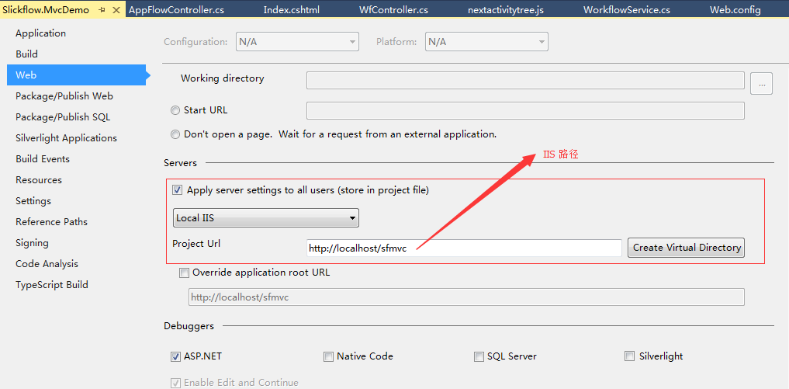

1. database connection string

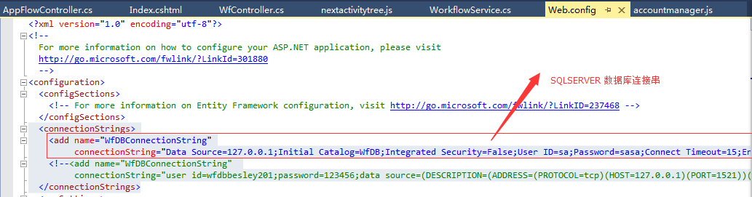

or appsettings.json

C:\Users\lg\AppData\Roaming\Tencent\Users\47743901\QQ\WinTemp\RichOle\V8~0TA2U{%$8L8Y@$`KAA73.png

* 1. **Slickflow WebDemo leave process DEMO**

1. IIS site

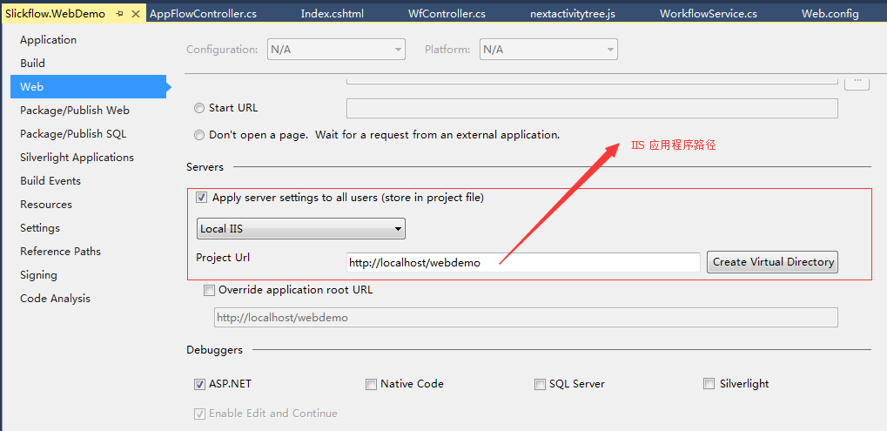

1. database connection string



1. **database environment**
2. **database creation script**

database defaults to the SQLSERVER version, and the script is in the database directory

1. **data sheet**

SQLSERVER2008 or above is recommended, and the list of engine-related database tables is as follows:

1. WfProcess — Process definition table
2. WfProcessInstance — process instance table
3. WfActivityInstance — activity instance table
4. WfTransitionInstance — Activity transition table
5. WfTasks — list of tasks
6. WfLogs — log table

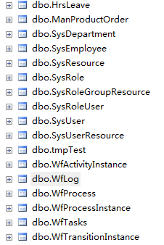

1. **Recommended Use**

Enterprise customers are recommended to use Enterprise, Ultimate, and Universe. For details on the specific versions, you can browse the official website and see the product list.